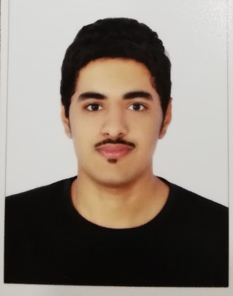**MOHAMED HUSAIN MATOOQ**



**+97338434248 b-m-w77@hotmail.com**



**Qurrayah - Bahrain Age : 22 years old**

**EDUCATION**



# Secondary School Naim Secondary Boys School 2011 – 2014

**--------------------------------------------------------------------------------------------------------------------------------**

**WORK HISTORY**

# Organita resturant 2015

# Electric extensions 2016

Security man in building **2017**

Delivery man in hungerstation **2018**

**--------------------------------------------------------------------------------------------------------------------------------**

**SKILLS**

# Work hard

# Work under pressure

# Teamwork

# Computer work

# Take responsility

# Learning fast

**LANGUAGES**

**Arabic**

**(**

**native**

**)**

**English**

**(**

**advanced**

**)**



**--------------------------------------------------------------------------------------------------------------------------------**